***LAB TASK: PSEUDOCODE***

1. **Find if the number is multiple of 5.**

START

INPUT num

IF numMOD5 == 0

THEN

OUTPUT num is a multiple

ELSE

OUTPUT num is not a multiple

ENDIF

END

1. **Check if a character is uppercase or lowercase.**

START

INPUT char

IF ASC(char) >= 65 AND ASC(char) <= 91

THEN

OUTPUT char is uppercase

ELSE

OUTPUT char is lowercase

ENDIF

END

**3. Create a small calculator which only does ‘+’ or ‘*‘Operations. (Hint: Take three variable inputs**

**with one being used for the operator)**

START

INPUT num1

INPUT num2

INPUT operator

Result = num1 operator num2

OUTPUT Result

END

**4.Check whether a given number is positive, negative, or zero.**

START

INPUT num

IF num > 0

THEN

OUTPUT num is positive

ELSE

IF num < 0

THEN

OUTPUT num is negative

ENDIF

ELSE

OUTPUT num is zero

ENDIF

END

**5.Determine if a person is a teenager (between 13 and 19 years old).**

START

INPUT age

IF age >= 13 AND age <= 19

THEN

OUTPUT you are a teenager

ELSE

OUTPUT you are not a teenager

ENDIF

END

***LAB TASK: ALGORITHMS***

**1. Implement an algorithm to determine if a given year is a leap year. A leap year is divisible**

**by 4, but not divisible by 100, except if it is also divisible by 400.**

1. START
2. ASK USER TO ENTER YEAR
3. SET RESULT1 TO (YEAR MOD 4)
4. SET RESULT2 TO (YEAR MOD 100)
5. SET RESULT3 TO (YEAR MOD 400)
6. IF RESULT1 IS EQUAL TO ZERO AND RESULT2 IS ALSO EQUAL TO ZERO, JUMP TO STEP 9
7. IF RESULT1 IS EQUAL TO ZERO AND RESULT2 IS NOT EQUAL TO ZERO, JUMP TO STEP 10
8. IF RESULT1 IS NOT EQUAL TO ZERO, JUMP TO STEP 11
9. IF RESULT3 IS EQUAL TO ZERO, JUMP TO STEP 10, ELSE JUMP TO STEP 11
10. OUTPUT LEAP YEAR AND JUMP TO STEP 12
11. OUTPUT NOT A LEAP YEAR
12. END.

**2. Implement an algorithm to count the number of occurrences of each character in a given**

**string.**

1. ASK USER TO ENTER STRING
2. SET LENGTH TO STRLEN(STRING)
3. SET i TO 1
4. SET CHARASCII TO ASC(STRING[i])
5. SET j TO 1
6. IF CHARASCII == ASC(STRING[j+1]) THEN counter1 = counter1 + 1
7. IF j == LENGTH(String) THEN JUMP TO STEP 10
8. j = j + 1
9. JUMP TO STEP 6
10. OUTPUT LETTER[i] REPEATS counter1 times
11. i = i + 1
12. JUMP TO STEP 4
13. END.

**3.Write an algorithm to calculate x raised to the power y (i.e., x y ) without using built-in**

**power functions.**

1. INPUT x
2. INPUT y
3. SET i TO 1
4. RESULT = x
5. IF y > 1, JUMP TO STEP 7
6. OUTPUT i AND JUMP TO STEP 11
7. RESULT = x * RESULT
8. i = i + 1
9. IF i != y, JUMP TO STEP 7
10. OUTPUT RESULT
11. END.

**4.Calculate the area of a circle given its radius r.**

1. INPUT r
2. SET RESULT TO (3.14 * r * r)
3. OUTPUT RESULT
4. END.

**5. Find the median of three given numbers.**

1. INPUT num1
2. INPUT num2
3. INPUT num3 \
4. IF (num1 > num2 AND num1 < num3) OR (num1 < num2 AND num1 > num3), JUMP TO STEP 7
5. IF (num2 > num1 AND num2 < num3) OR (num2<num1 AND num2 > num3), JUMP TO STEP 8
6. IF (num3 > num1 AND num3 < num2) OR (num3 < num1 AND num3 > num2), JUMP TO STEP 9
7. OUTPUT num1 is the median AND JUMP TO STEP 10
8. OUTPUT num2 is the median AND JUMP TO STEP 10
9. OUTPUT num3 is the median AND JUMP TO STEP 10
10. END.

**GIT SCREENSHOTS+LINK**: https://github.com/Fawwaz-Adil/k240610

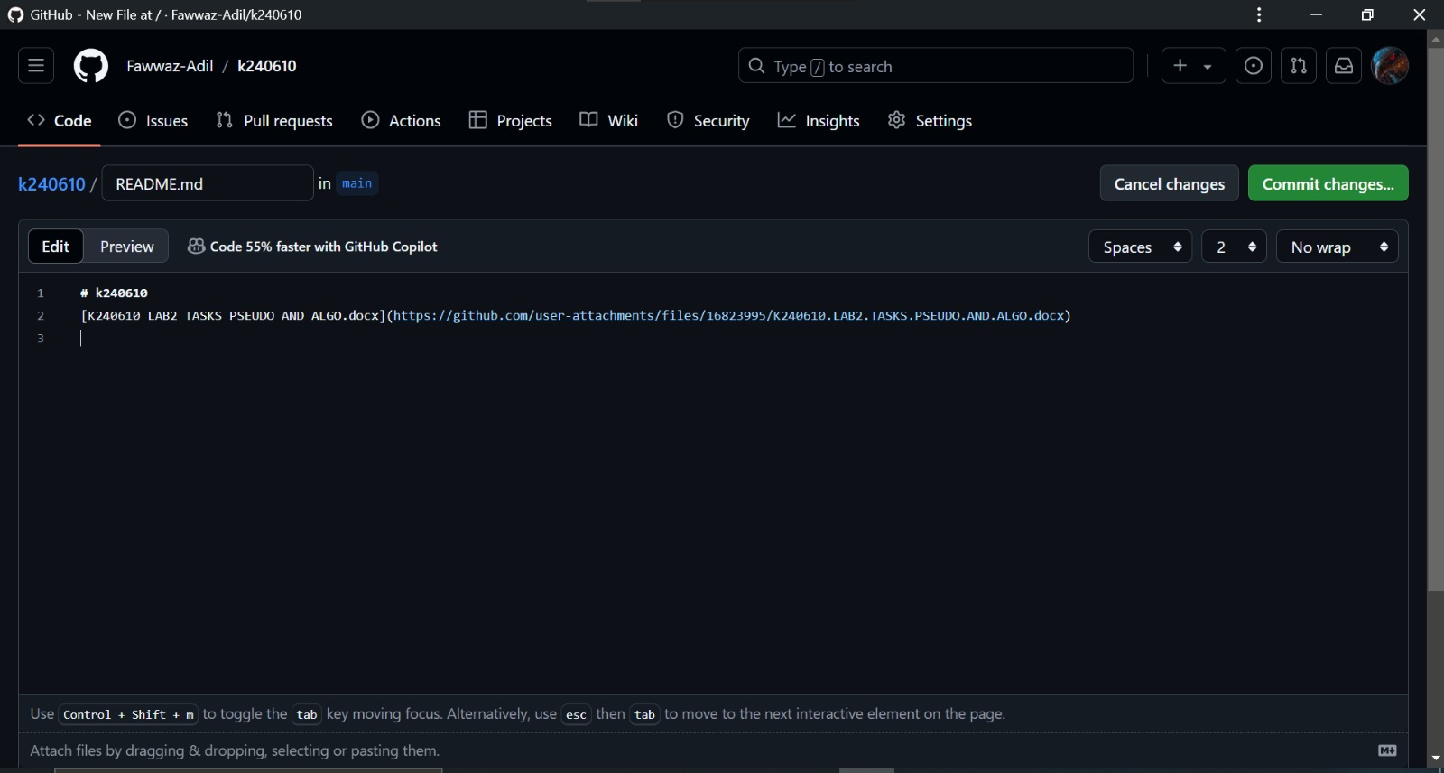

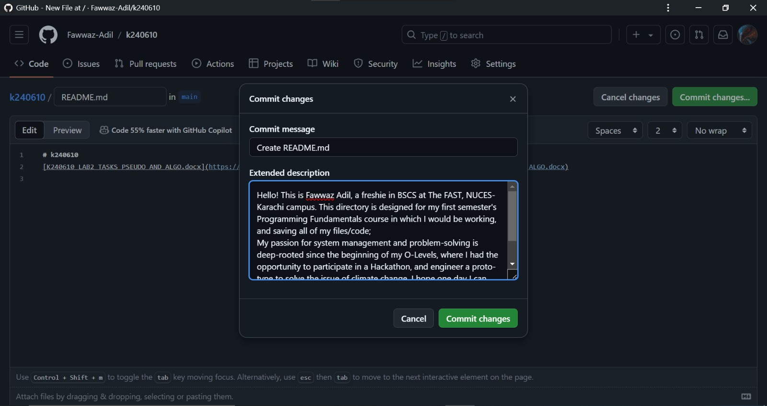

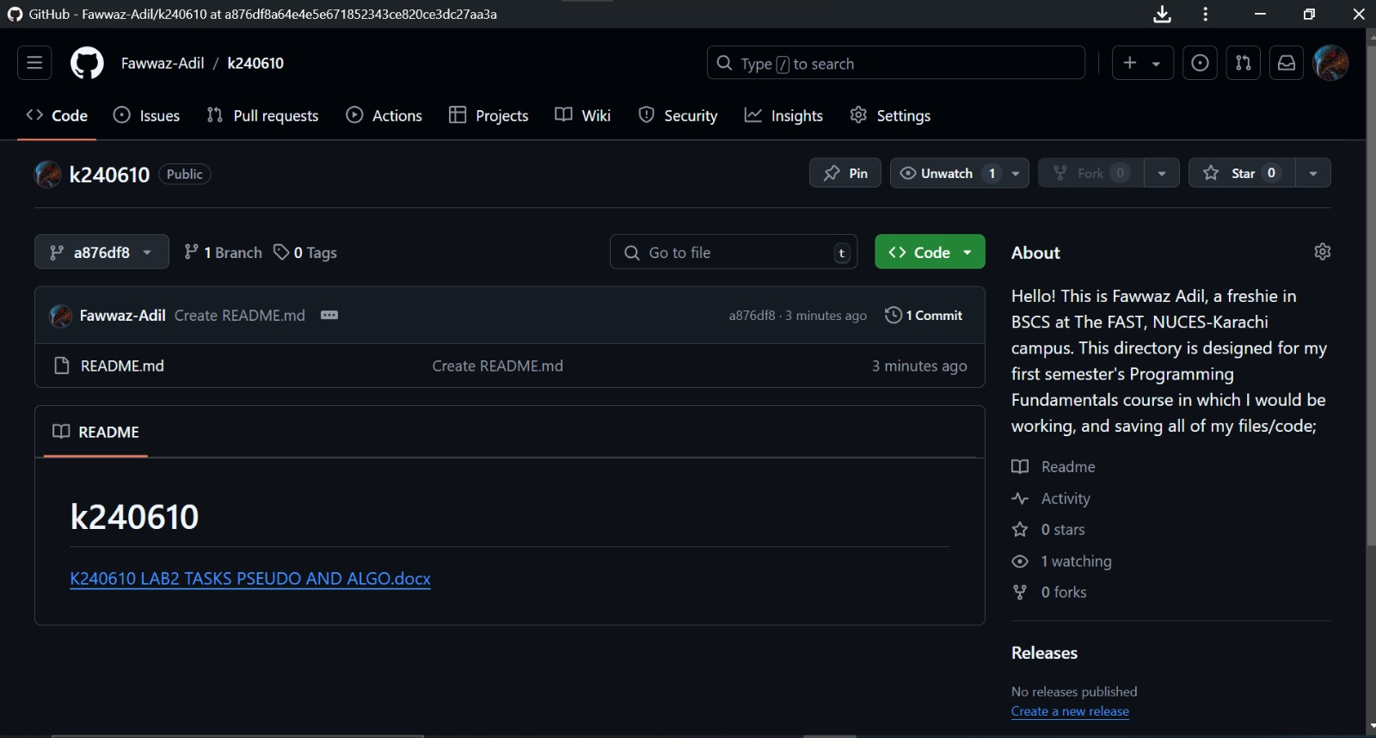

**Flowchart:**

